**(1) Sorting one column :**

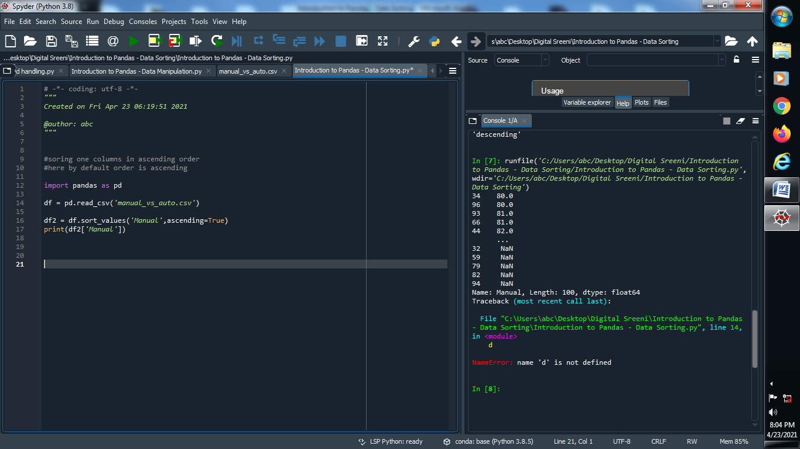

**Output :**



**(2) Print Subsets :**

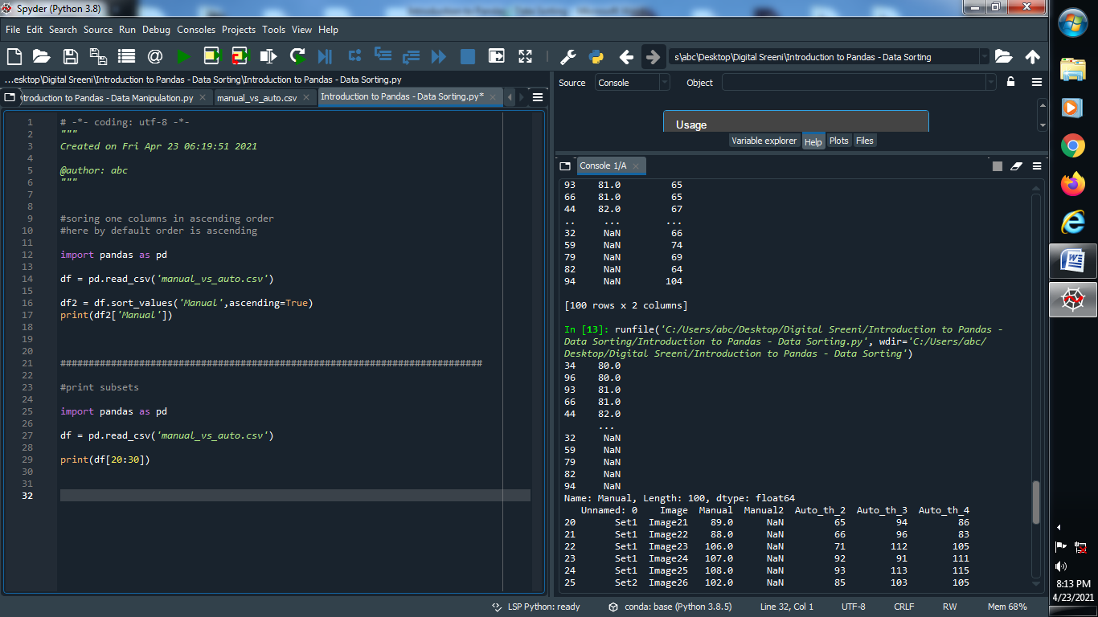

**Output :**

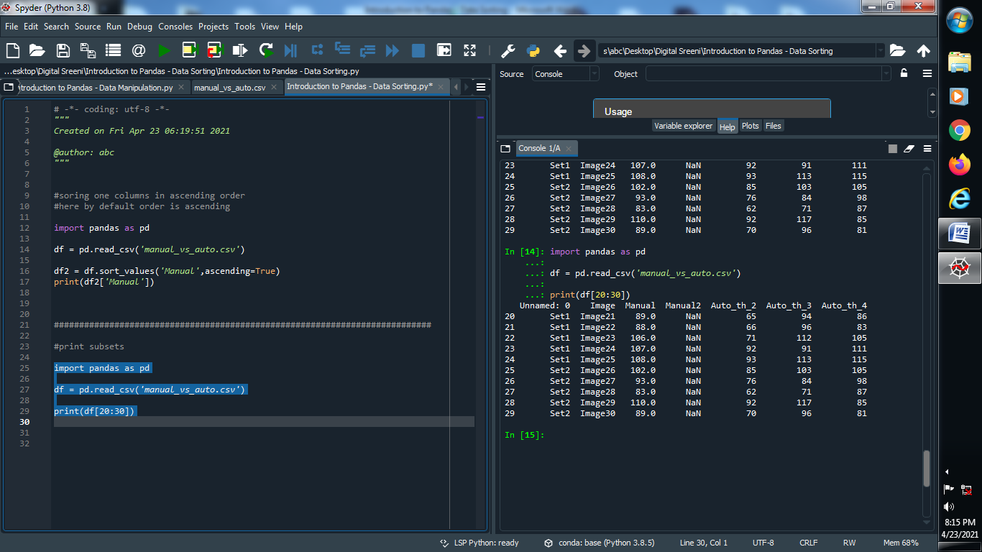

**(3) Find particular subset of multiple columns :**

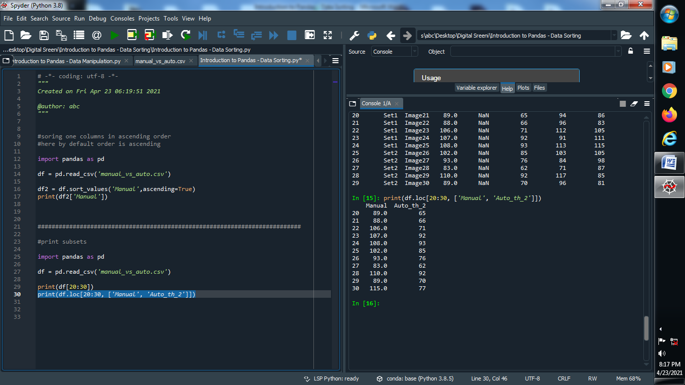

**OUTPUT :**



**(4) Select row using row values :**

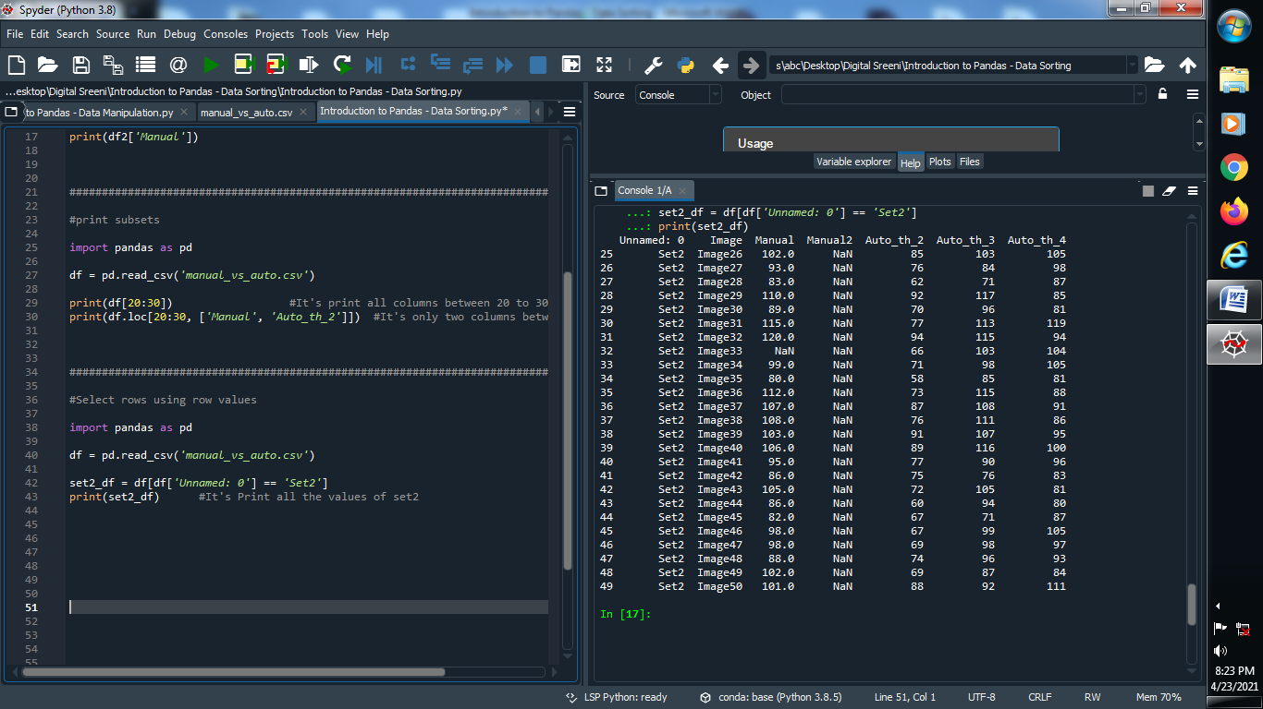

**Output :**



**(5) Print maximum and minimum values :**

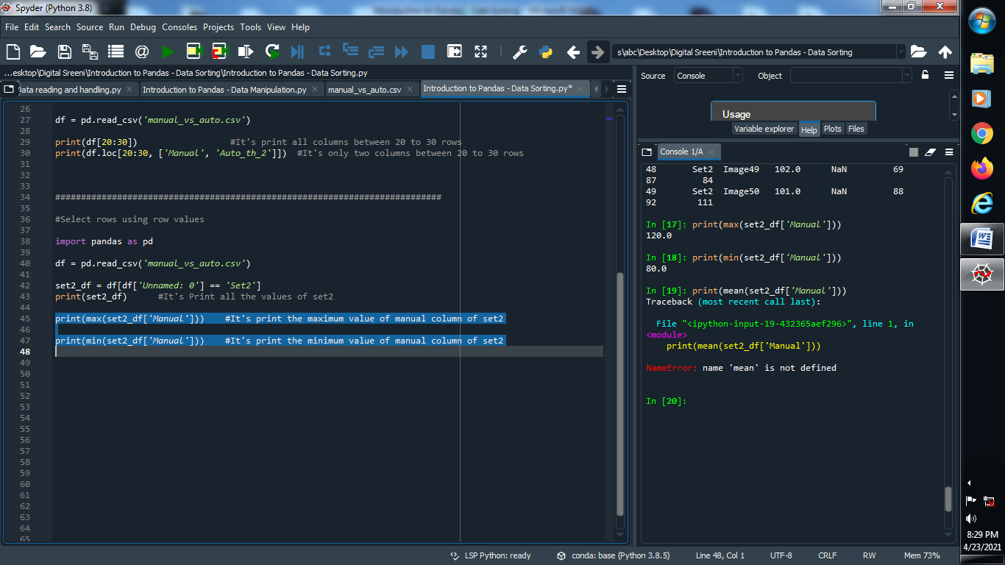

**Output :**



**(6) Find the values which is greater than 100 in True or False manner :**

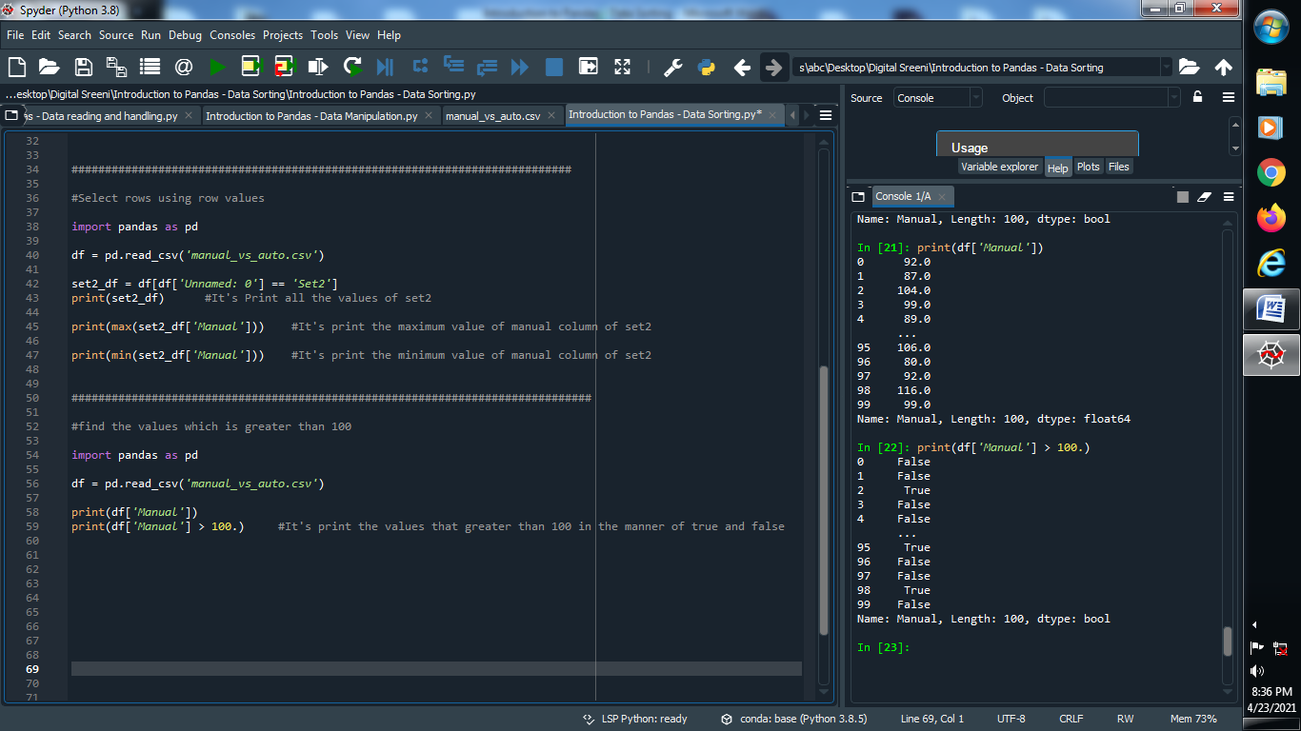

**Output :**



**(7) Find the values which is greater than 100 in numbers :**

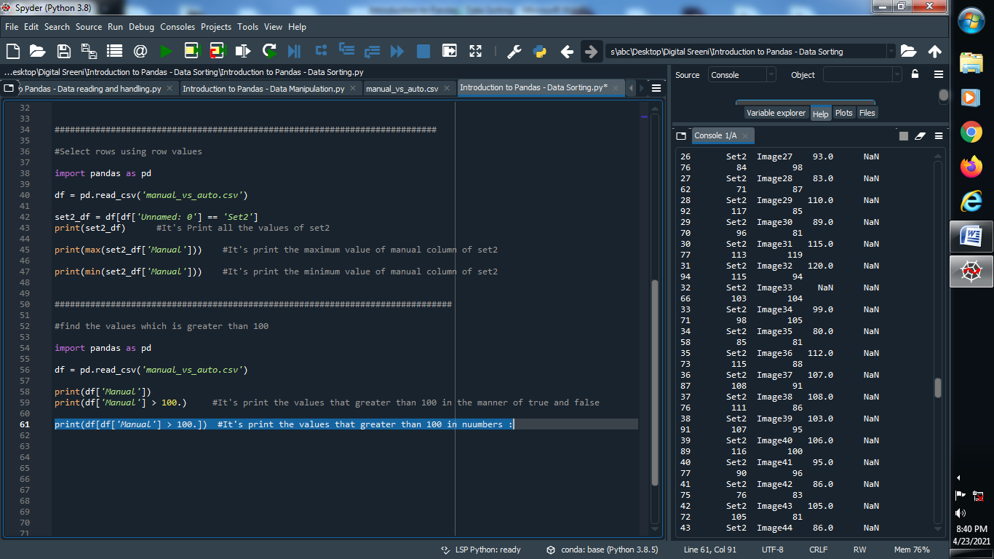

**Output :**

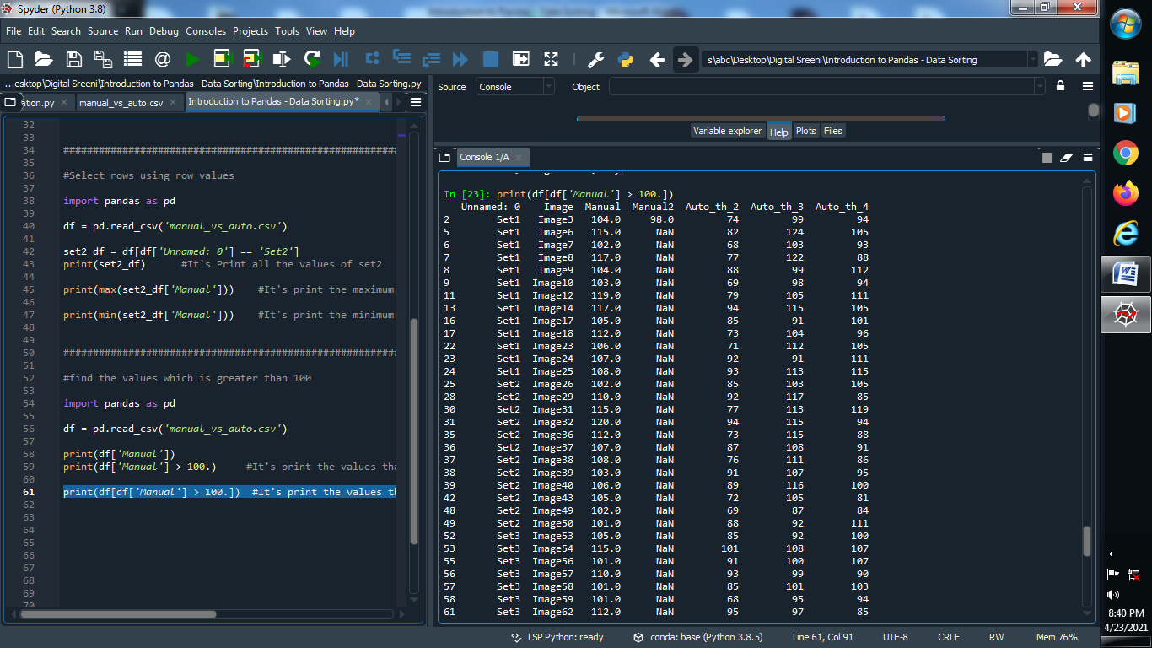

**(8) Find the values of two columns :**

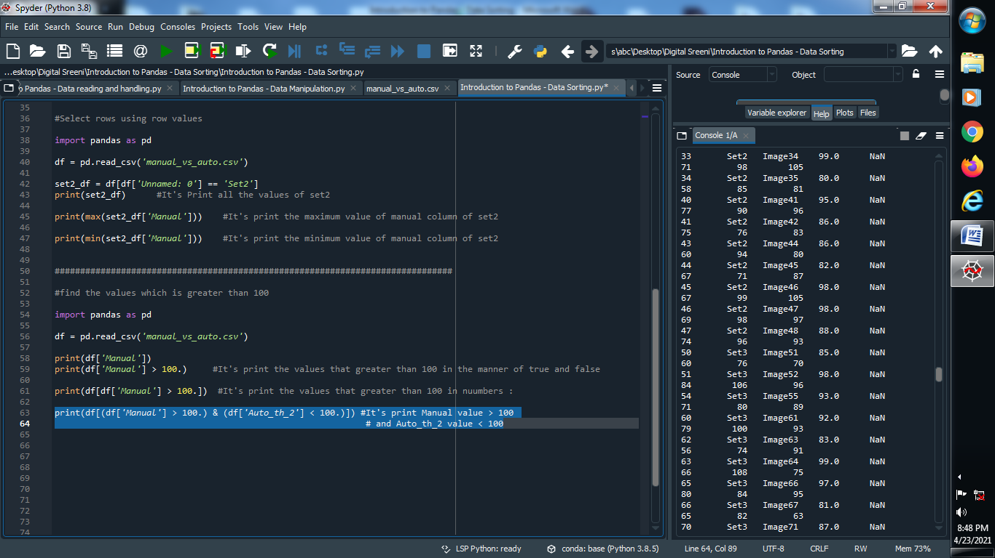

**Output :**

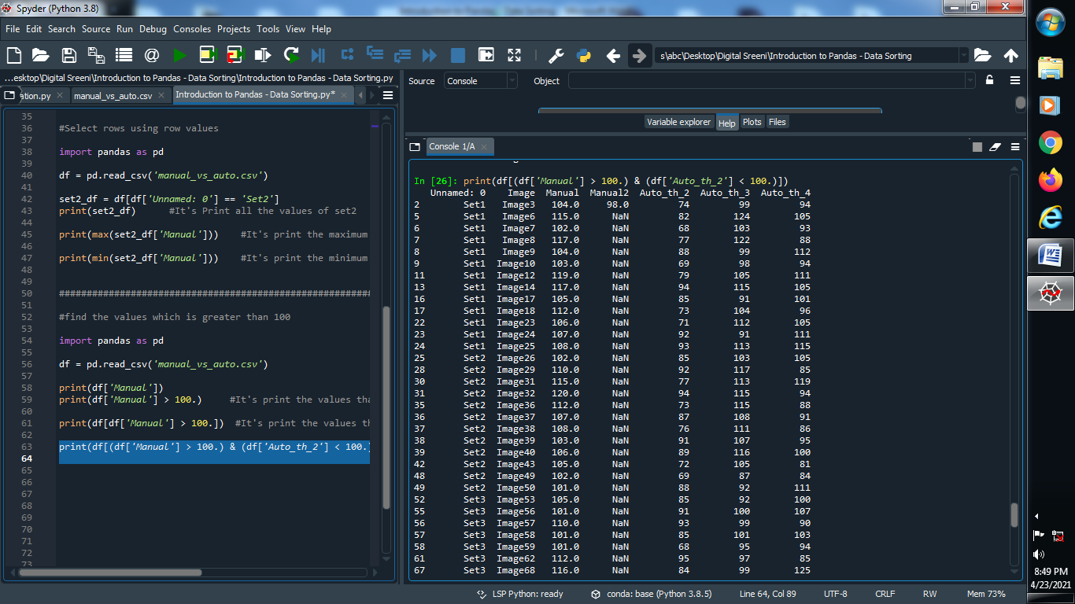

**(9) Iteration Concept :**

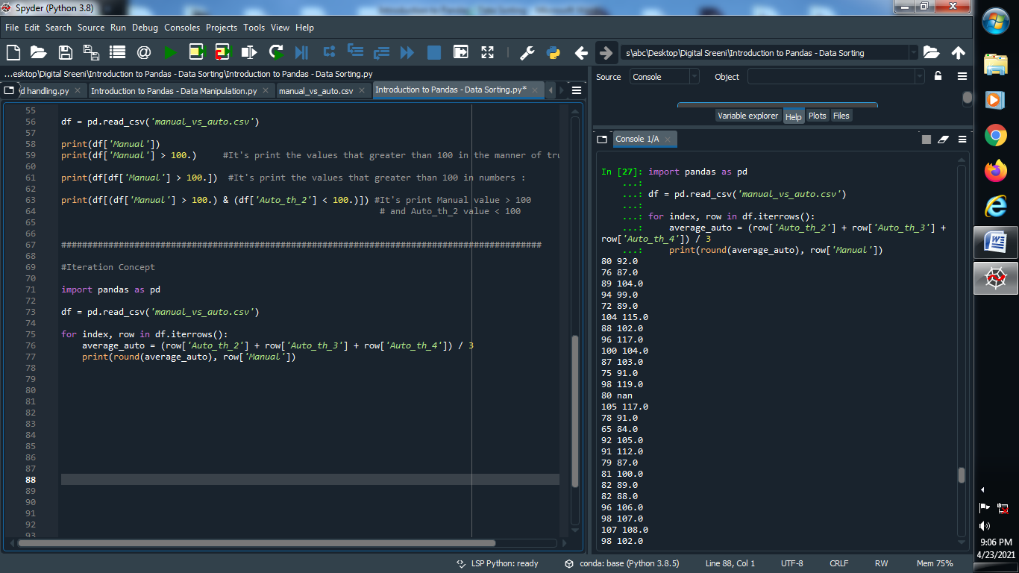

**Output :**

